**Junit_Basic Testing Exercise**

**Exercise 1: Setting Up JUnit**

* **New Java Project**

* **Calculator.java (a method for testing)**

* **pom.xml**

* **CalculatorTest.java(a test class)**

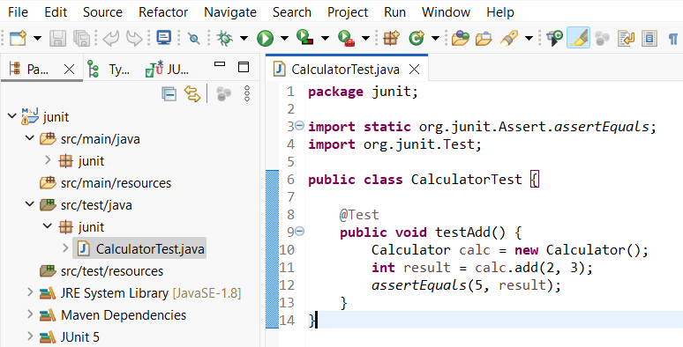

* **Test Results (**Right click on **CalculatorTest.java -> Run As ->**

**JUnit Test)**

**Exercise 3: Assertions in JUnit**

* **Scenario :** Need to use different assertions in JUnit to validate our test results.

Following are the different assertions:-

* + - assertEquals
    - assertTrue
    - assertFalse
    - assertNull
    - assertNotNull
* **Calculator.java (a method for testing all the assertions)**

* **AssertionsTests.java (tests using various JUnit assertions)**

* **Test Results (**Right click on **AssertionsTest.java -> Run As ->**

**JUnit Test)**

**Exercise -4: Arrange-Act-Assert (AAA) Pattern, Test Fixtures, Setup and Teardown Methods in JUnit**

* **Scenario:** You need to organize your tests using the Arrange-Act-Assert (AAA) pattern and use setup and teardown methods.
  + - **Arrange –** It is where all necessary setup is performed.
    - **Act –** It is the phase where all the method or functionality being tested is executed.
    - **Assert –** It is the phase where the validation is done using different assertion methods.
* **Calculator.java (a method for testing)**

* **CalculatorTest.java (test class using AAA + Setup/Teardown)**

* **Test Results (**Right click on **CalculatorTest.java -> Run As ->**

**JUnit Test)**

* **Console Output**

